Inguinal canal

Etymology
- Inguinalis = L . Of the groin
- Groin = depression in ground
- Loin = side of the animal used for food
- Biblical translation = the part of the body that should be covered
- And about which cloths are bound – loin cloth

[SVG] inguinal canal position anterior abdominal wall.svg|animations="XMLID_1_:pulse"[/SVG]

Definition:
Passage superficial to deep inguinal ring for transmission of spermatic cord in male and round ligament in female

Length
4 cms

Contains
- Spermatic cord in males
- Round ligament in females
- Ilioinguinal nerve in both

[TIP]Inguinal canal is the path traced by the descending testis

Extension:
- From deep to superficial inguinal rings
[SVG] extension of inguinal canal labels.svg[/SVG]
[TIP]Learn to draw the diagram
[YOUTUBE]https://youtu.be/j8kKt4QgkKw

Boundaries

Anteriorly:
- Skin and superficial fascia
- Aponeurosis of external oblique muscle
- Lateral 1/3rd by muscular fibres of internal oblique
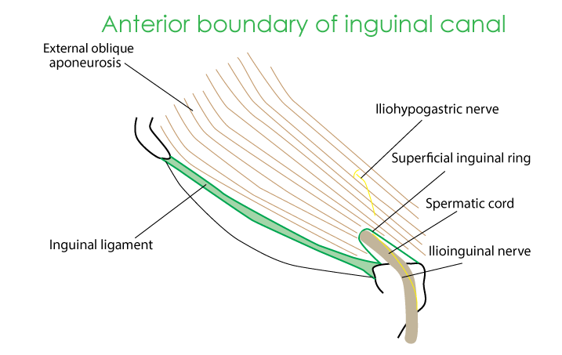
[TIP]Learn to draw the diagram
[YOUTUBE] https://youtu.be/etpEgetqhJ4

Posteriorly
- Reflected inguinal ligament
- Falx inguinalis – Conjoint tendon
- Transversalis fascia
  - Separates it from extraperitoneal connective tissue and peritoneum

[SVG]posterior boundry of inguinal canal.svg[/SVG]

[TIP]Learn to draw the diagram
[YOUTUBE] https://youtu.be/iRQ7AeE6FYk

Superiorly
- Arched fibres of internal oblique and transversus abdominis

Inferiorly
- By union of transversalis fascia
- With inguinal ligament
- Medial end – lacunar ligament

[SVG]inferior wall of inguinal canal.svg[/SVG]

[TIP]Learn to draw the diagram
[YOUTUBE] https://youtu.be/BdLdgnJW500

Contents
[YOUTUBE]https://youtu.be/uGPP-3X5OwQ
Spermatic cord in males
Round ligament in females
Ilioinguinal nerve in both
[CLINICAL]Ilioinguinal nerve do not pass through deep ring
[SVG] spermatic cord.svg[/SVG]

Surface marking
[SVG]surface marking.svg[/SVG]

Inguinal canal in infants
- 1 – 1.5 cms
- Horizontal

Applied anatomy
Although the inguinal canal is arranged such that the weaknesses in the anterior abdominal wall caused by the deep and superficial inguinal rings are supported, the region remains a potential cause of herniation.

Hernia
[CLINICAL]Normal or abnormal protrusion of part/whole of an organ/tissue through a normal/an abnormal opening in the wall containing it
[SVG]indirect inguinal hernia.svg[/SVG]
[SVG]direct inguinal hernia.svg[/SVG]

Inguinal hernia
Abnormal protrusion of abdominal contents in the inguinal region
- Direct/indirect
- Inguinal/inguinoscrotal (Incomplete/complete)
- Congenital/acquired
- Uncomplicated/complicated
- Content – omentocele, enterocele

Mechanisms to maintain integrity of inguinal canal
- Flap – valve mechanism
  - Canal is oblique
- Guarding of inguinal rings
  - Deep ring – internal oblique muscle
  - Superficial ring – conjoint tendon
- Shutter mechanism
  - Roof is pulled and approximated like a shutter
- Ball – valve mechanism
  - Cremaster pulls testis upwards

[SVG] mechanism of inguinal canal.svg[/SVG]

___MCQ_START___
Q1. The inguinal canal is best defined as:
A. A passage extending from the umbilicus to the pubic symphysis
B. A defect in the transversalis fascia transmitting inferior epigastric vessels
C. An oblique passage extending from the deep to the superficial inguinal ring transmitting the spermatic cord or round ligament[CORRECT]
D. A vertical canal transmitting femoral vessels
___

Q2. Which of the following structures passes through the inguinal canal but does not enter through the deep inguinal ring?
A. Spermatic cord
B. Round ligament of uterus
C. Ilioinguinal nerve[CORRECT]
D. Vas deferens
___

Q3. The posterior wall of the inguinal canal is mainly reinforced by:
A. Aponeurosis of external oblique
B. Inguinal ligament
C. Falx inguinalis (conjoint tendon)[CORRECT]
D. Cremasteric muscle
___

Q4. The deep inguinal ring is located:
A. Medial to inferior epigastric artery
B. Posterior to rectus abdominis
C. At the medial end of inguinal ligament
D. Lateral to inferior epigastric artery[CORRECT]
___

Q5. Hesselbach’s triangle is bounded by all except:
A. Inferior epigastric artery
B. Lateral border of rectus abdominis
C. Inguinal ligament
D. Pectineal ligament[CORRECT]
___

Q6. The primary mechanism preventing herniation through the inguinal canal includes all except:
A. Obliquity of the canal
B. Shutter mechanism of the roof
C. Guarding of inguinal rings
D. Vertical orientation of the canal[CORRECT]

___MCQ_END___

